**Smart meter DSMR-API adapter**

**Areks special ;-)**

Step 1: Start to plugin only the part in the red box (see picture below). So remove the cables.

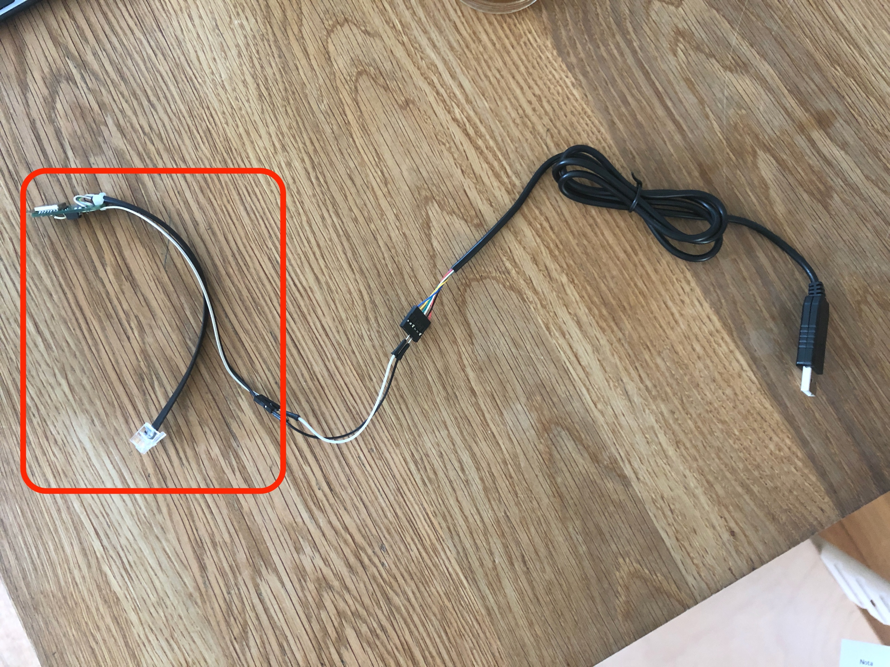

Step 2: plug the adapter in the P1 port and follow the instruction in the Wifi Configuration part of this manual.

Normally the adapter starts up and you should enter the website. In the webpage you can change the settings (wheel on the upper right). After that on the main page click Telegram. This should show the telegram (first telegram could take some seconds).

Step 3: No telegram

When the telegram doesn’t showup in the webinterface the second you could analyse the problem with the cable.

3a: remove the DSMR adapter from the P1

3b: reconnect the wires (black and white in the correct way white on white and block on black)

3c: plug the adapter in the P1 and plug the usb in your computer

3d: when you have installed Arduino IDE you should change the port, baudrate (112500). Then in settings hit monitor serial

The telegram should show up every 2 – 10 seconds.

Success!!

**Introduction**

This document describes the installation and configuration of the DSMR API on hardware version 2.0. The hardware normally comes with working software. If not or if you want to adjust it, go to the software section.

This project is a further development based on the pioneering work of Willem Aandewiel. A number of improvements have been made to the web layout, page loading and interface messages. MQTT interface is unchanged. API interface is version 2.0 and therefore adapted (different structure).

For more information about Willems project, see <https://mrwheel-docs.gitbook.io/dsmrloggerapi/>

**Wifi Configuration**

The adapter builds its own WiFi hotspot for configuration after connection the adapter to the P1 port of the Smart Meter. This hotspot can be recognized by the Wi-Fi name DSMR API - ?????.

Make sure you connect to this network with your computer or mobile device. An update screen is automatically displayed in which the WiFi settings can be seen. See the picture below.

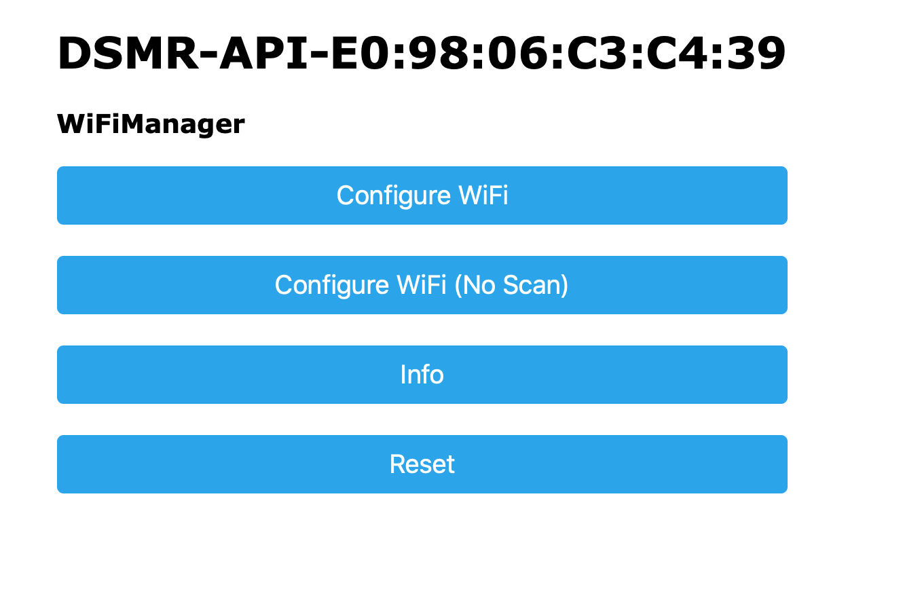

1. Click on “Configure Wifi”
2. Choose your network
3. Enter the password
4. Click on “Save”
5. The DSMR adapter reboots

From this moment on, the adapter will be available at: <http://dsmr-api.local>

This name can be changed, in the settings.

**Read Smart Meter**

There are three ways to interact with the smart meter via this adapter, namely:

1) Via the web interface of the adapter (http: //dsmr-api.local/)

2) Through the rest api (http: //dsmr-api.local/api/v2/hist/hours); retrieve the data yourself at the desired time; see API info in the web interface for more information

3) Via MQTT; adapter pushes the data to the mqtt broker every x seconds; see below the configuration of mqtt

**Configuration**

This is done via the web interface. In the browser, open <http://dsmr-api.local>

Press the wheel on the right of the menu. The settings screen below is visible.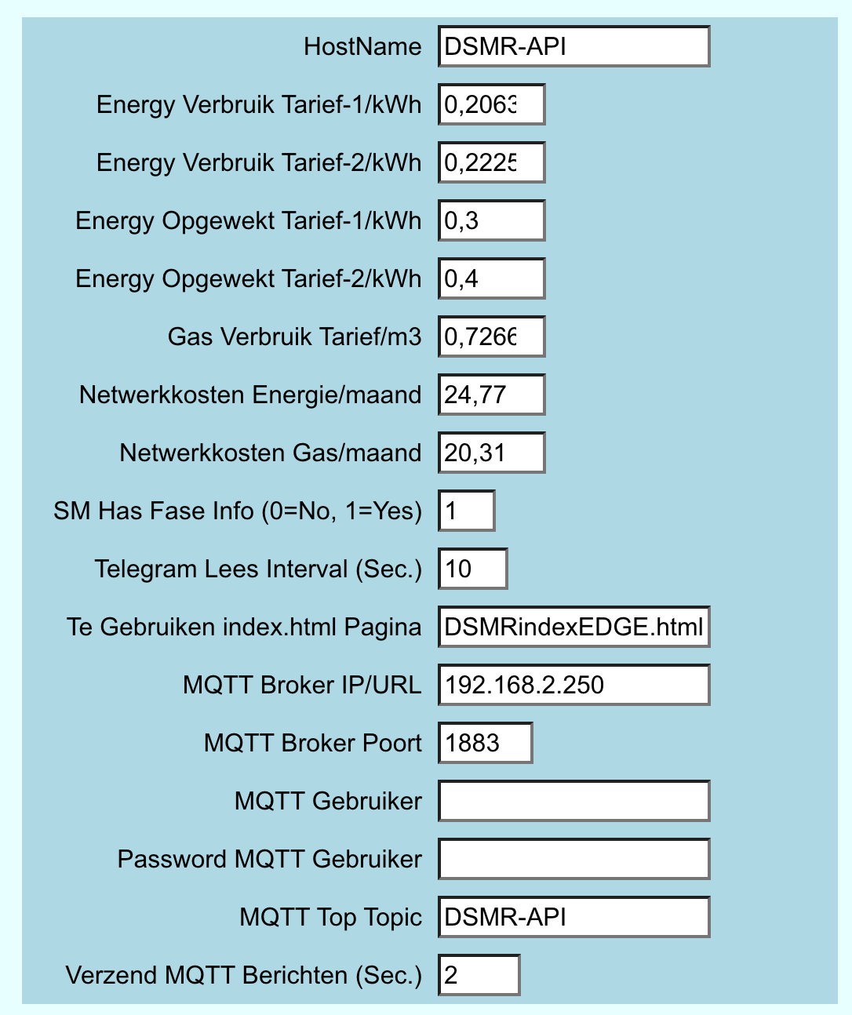

1 - MQTT

To activate the mqtt interface, the following must be set.

1) HostName (mqtt broker)

2) MQTT Broker IP / URL: (ex: 192.168.2.250)

3) Port (default: 1883)

4) MQTT Top Topic of this adapter (default: DSMR API)

5) Optional: password and Username

6) Sending MQTT messages: at what frequency the messages are sent. In this example every 2 seconds while the reading frequency is 10 seconds. A bit nonsensical the current setting ;-) since 5 times the same value is sent.

7) Press Save at the top right to save the settings and activate mqtt

2 – Tarifs

The rates can also be entered in the same settings screen so that the amounts are included in the cost calculation. Adjust this based on your contract with your energy supplier.

Pay attention! the amounts in the adapter may differ from your real bill and are therefore approximate.

3 – Other settings

The frequency of reading can be set.

In addition, also the frequency of sending the MQTT data.

**Flashen / Flashing / Updating**

Flashing should be done via an FTDI interface. The connections for this interface are located on J2.

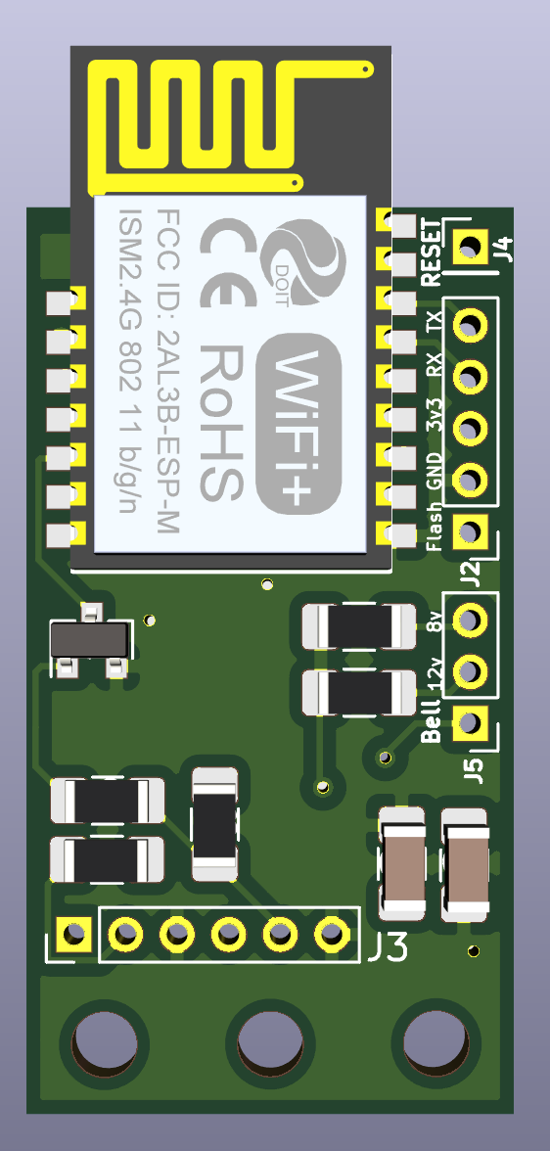The pinout :

1. Flash (squar pad / red arrow); Flash to GND and reset to start in program mode
2. GND
3. 3.3Volt
4. RX
5. TX

J4 is reset. Reset = GND

The software can be found on: <https://github.com/mhendriks/DSMR-API-V2>

**Connecting extra signal**

An additional input can be connected to J5. The intention is to tap an 8 or 12 volt bell so that the ring signal can also be sent to, for example, your telephone or flash a living room lamp. How does this work?

1) Check the bell transformer voltage.

2) Pull a 2 core cable to the bell and connect the two wires

3) Connect 1 wire to J5-Bell

4) Connect the other wire to 8 or 12Volt (depending on the transformer voltage)

If the transformer is of the DC type, the two wires may have to be reversed.

Instellen Domotica oplossing